**Part 9 - Login Logout**

Here we are going to learn about

1. Login Template & Component
2. Drop down logout functionality
3. LOGIN TEMPLATE & COMPONENT
4. Please create User-Login component

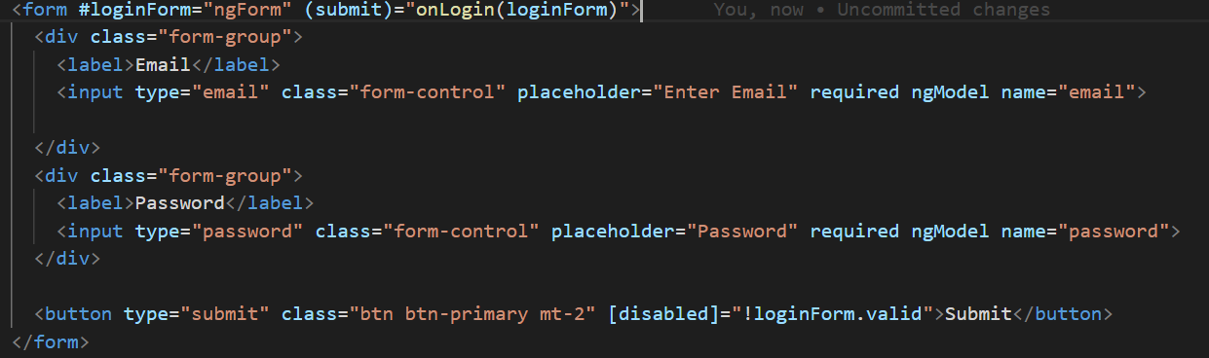

1. Modify user service and add below method

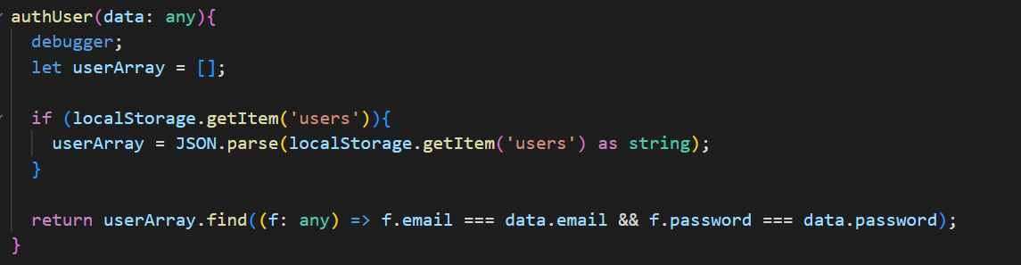

Currently, we use local storage as storage system.

1. Creating onLogin method

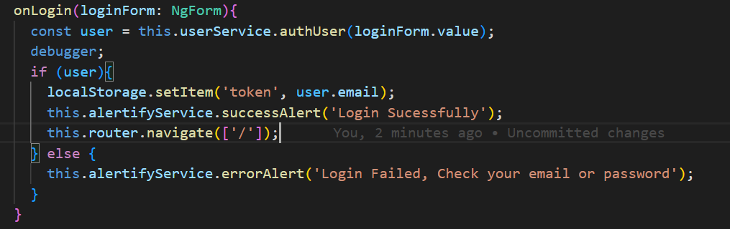

1. DROP DOWN LOGOUT FUNCTIONALITY

Before continuing the development process please install ngx-bootstrap in order to use dropdown button.

- open ngx-bootstrap link <https://valor-software.com/ngx-bootstrap/#/>

- click get started to see documentation

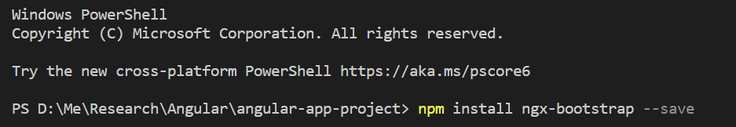

Once the installation is completed , it will be add bootstrap configuration on

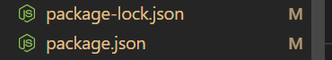

- go to the component documentation

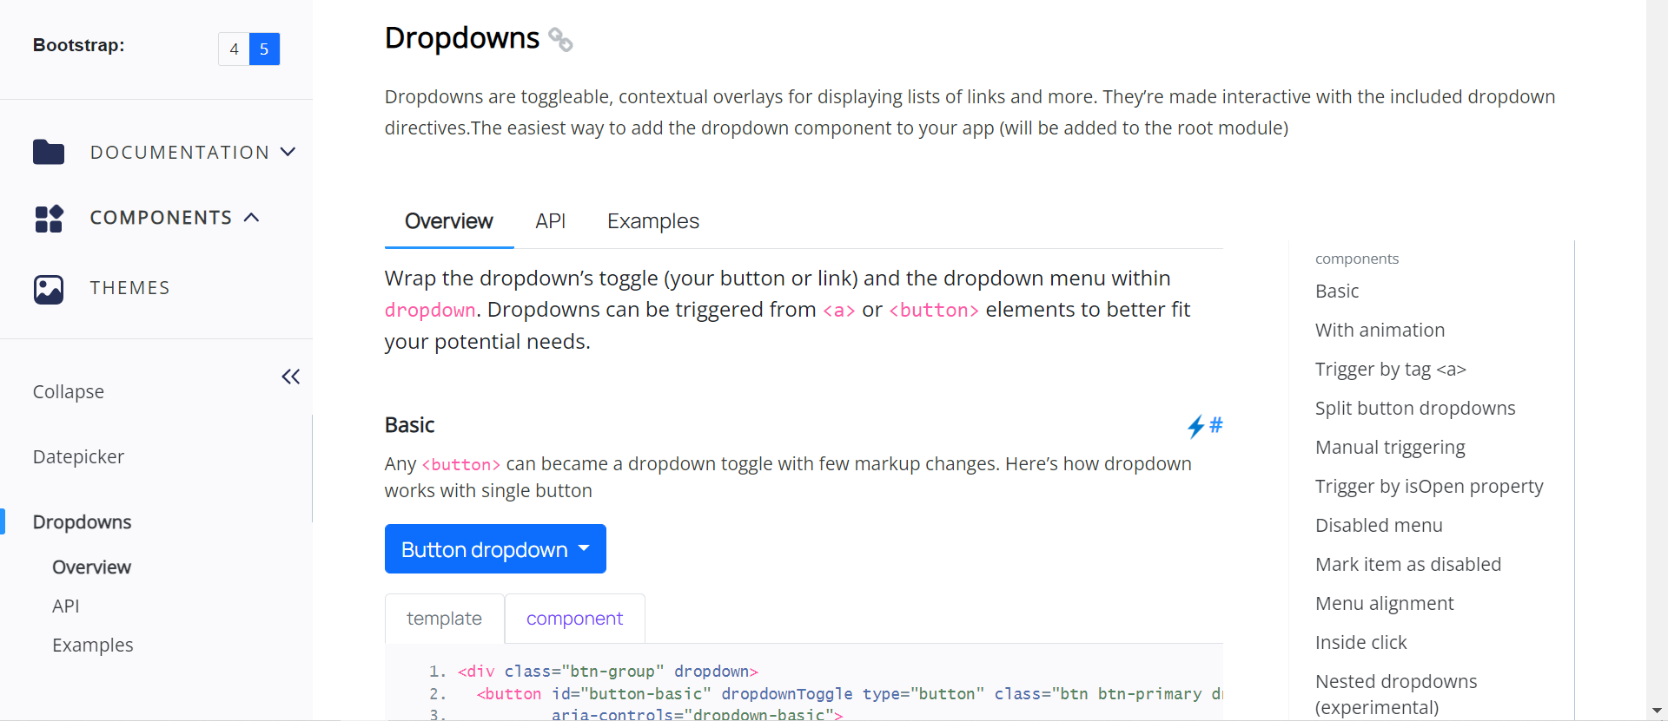

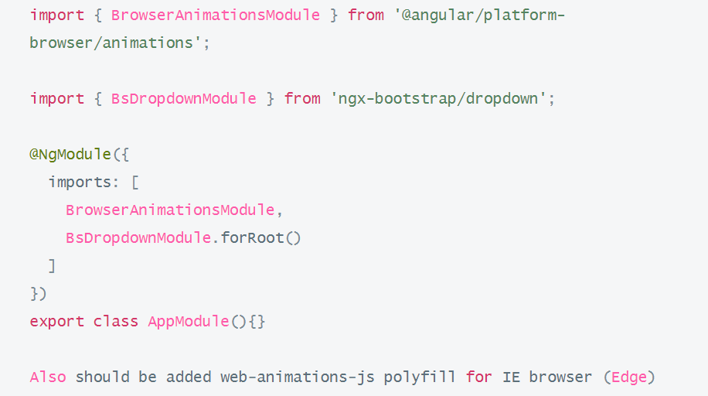

Modify our app.module



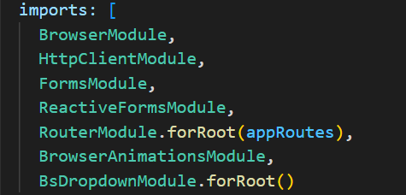

Open nav-bar component

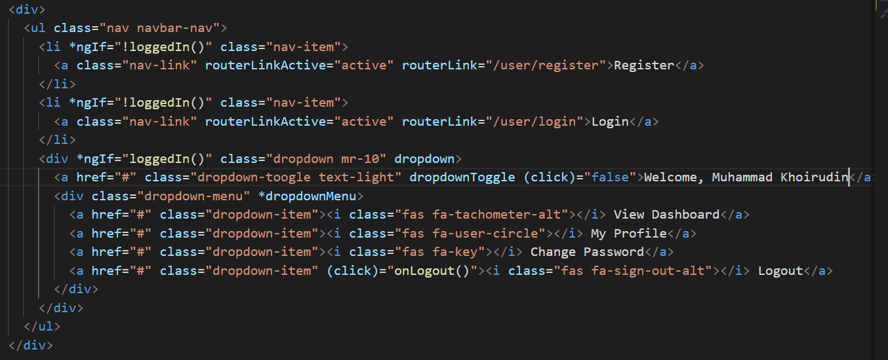

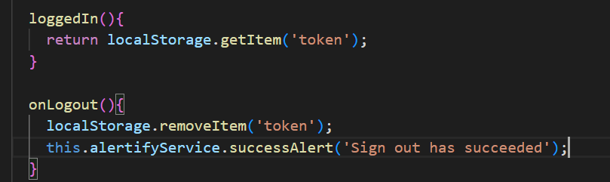

Open index.html add font awesome link

